The Solution by Ulvi Bajarani, SID 20539914

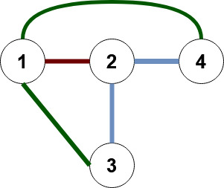

The undirected graph G=(V, E) where
V={1,2,3,4}, and
E={{1,2}, {2,3},{3,1},{2,4},{1,4}}.

There are several paths from node 3 to node 4:
a) 3 to 2, and 2 to 4 (indicated by light-blue edges);
b) 3 to 1, and 1 to 4 (indicated by green edges);
c) 3 to 1, 1 to 2 (indicated by the brown edge), and 2 to 4;

